Carrier/curcumin microparticles obtained by supercritical antisolvent precipitation

Iolanda De Marco*
Department of Industrial Engineering, University of Salerno, Via Giovanni Paolo II, 132
84084 Fisciano (SA), Italy
*Corresponding author E-Mail: idemarco@unisa.it

1. Introduction
Viral infections are still considered a persistent public health problem today. Viruses can be defined as non-living submicroscopic agents, composed mostly of RNA or stretches of DNA, capable of replicating and mutating within the host organism causing organoleptic and metabolic changes [1].
Coronavirus disease 2019 (COronaVIrus Disease 19, COVID-19) is an infectious respiratory disease caused by SARS-CoV-2, belonging to the coronavirus family. The first cases were found in China, in Wuhan, in December 2019, and it was declared a pandemic in March 2020. Its rapid spread has caused severe difficulties in monitoring infected cases and drafting containment protocols in all countries involved.
Several natural substances belonging to different classes, most with antioxidant properties, have been considered excellent candidates for combating the COVID-19 pathology. In particular, those that have binding energy or a docking score similar to the drugs commonly used today and believed most effective are: polyphenols such as flavanones (including naringenin, quercetin and kaempferol) and flavones (including luteolin), terpenes and sesquiterpenes, curcumin, peptides, epigallocatechin gallate (EGCG), fatty acids and oleuropein [2,3].
Curcumin has been focused on these purposes. However, the effectiveness of this compound is limited by its poor solubility in water and, consequently, low bioavailability, as well as high sensitivity to light and heat. To overcome these problems, the active principle has been micronized through the supercritical antisolvent process (SAS) using two different types of carriers, namely β-cyclodextrin (β-CD) and polyvinylpyrrolidone (PVP). In particular, while aiming at a microparticle morphology of the powders in both cases, simple coprecipitates (microspheres) with PVP or inclusion complexes with β-CD were prepared to protect the active ingredient from degradation phenomena and increase its dissolution rate in an aqueous environment.
2. Materials and methods
β-cyclodextrin (βCD, purity 99.9 %) , polyvinylpyrrolidone (PVP, average molecular weight of 10 kg/mol) and curcumin (CURC, purity > 65 %) were provided by Sigma–Aldrich (Italy). Dimethylsulfoxide (DMSO, purity 99.5 %) was purchased from Carlo Erba (Italy). Carbon dioxide (CO₂, purity 99 %) was supplied by Morlando Group s.r.l. (Italy).
The experiments were performed in a homemade laboratory plant. Carbon dioxide is fed to the precipitation chamber with an internal volume of 0.5 L through a high-pressure pump. The liquid solution is prepared by dissolving the solutes in DMSO. The prepared solution is sprayed into the precipitation vessel through a stainless-steel nozzle through another pump. A micrometric valve regulates the pressure. The precipitated powder is collected at the bottom of the precipitation vessel on a stainless-steel filter. The liquid solvent is recovered in a separator located downstream of the vessel. The flow rate and the total amount of delivered CO₂ are measured at the exit of the separator by a rotameter and a dry test meter, respectively.
The morphology of the precipitated powders was determined by Field Emission Scanning Electron Microscopy (FESEM, mod. LEO 1525, Carl Zeiss SMT AG, Oberkochen, Germany). Fourier-transform infrared (FTIR) analysis was carried out using a Bruker spectrophotometer (Bruker Optics, Ettlingen, Germany), model Vortex 70 FT-IR (scan wavenumber range of 4000–450 cm⁻¹, resolution of 0.5 cm⁻¹ as the mean of 16 measurements). The dissolution kinetics of not processed or released from SAS-prepared samples CURC were studied using a UV/vis spectrophotometer (model Cary 50, Varian, Palo Alto, CA). The analyses were performed at a wavelength of 425 nm. In agreement with the literature, the dissolution tests were achieved in phosphate-buffered saline solution (PBS) at pH 6.8 (Rezaei and Nasirpour, 2019). Samples containing 2 mg of equivalent CURC were incubated in 300 mL of PBS at pH 6.8, continuously stirred at 150 rpm, and heated at 37 °C.
3. Results and discussion
Curcumin was coprecipitated with βCD (Figure 1a) or PVP (Figure 1b) at different process conditions. In particular, the effect of the pressure, the concentration of the liquid solution, and the ratio between the carrier and curcumin were investigated. At the optimized operating conditions, well-defined microparticles with a fast release were obtained using both the carriers.
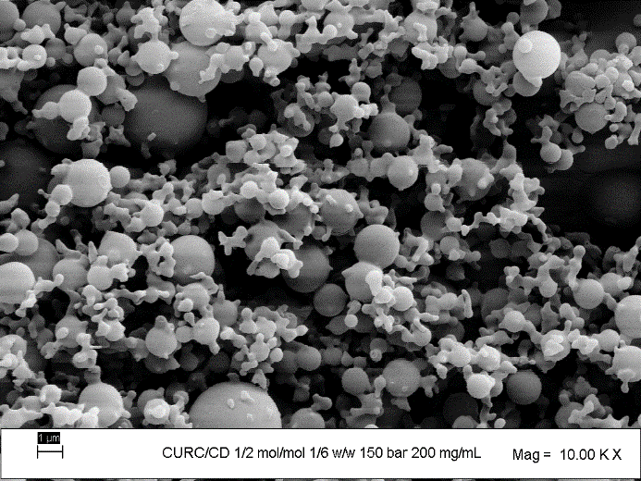
Figure 1. FESEM images of curcumin microparticles precipitated through the SAS process using β-cyclodextrin (on the left) and PVP (on the right) as the carriers.
4. Conclusions
The SAS process was effective using either cyclodextrin or PVP as carriers for the coprecipitation of curcumin. The production of βCD-based complexes or PVP-based coprecipitates allows to speed up the dissolution of curcumin, achieving the intended purposes. However, the use of β-CD compared to PVP seems to be more advantageous, as it reduces the amount of carrier in composite powders while ensuring a rapid release. Furthermore, cyclodextrin has the further advantage of allowing more significant powder recovery with the same process times. With the same injected solution, the concentrations used with CD are significantly higher than those used with PVP. Ultimately, this study made it possible to achieve the intended purpose, i.e., to produce composite systems capable of improving the therapeutic efficacy of curcumin, useful in the prevention or as adjuvant treatments for the pathology of COVID-19.
References
- S. Modrow, D. Falke, U. Truyen, H. Schatzl, Molecular Virology, Springer-Berlin-Heidelberg, 2013, pp. 17-30.
- A. da Silva Antonio, L. Silveira Moreira Weidemann, V.F. Veiga-Junior, RSC Adv. 10 (2020) 23379-23393.
- K. Chojnacka, A. Witek-Krowiak, D. Skrzypczak, K. Mikula, P. Młynarz, J. of Functional Foods 73 (2020) 104146-104153.

